Phragmites x CO₂ X N Harvest Manual 2024
Last Edited on 30 July 11 by AP
Materials
- Digital calipers
- 7 cm² sampling square for patens clip plots
- Coin envelopes for Phragmites leaves
- 3 m measuring stick (made from 1” or 1.5” PVC)
- Pre-labelled paper bags for clip plots
- After all panels are removed, first install the three PVC cross sections. These snap into the PVC skeleton of the chamber, with the larger diameter PVC at the two ends of the chambers, and the smaller diameter in the middle section.
- Lay the aluminum angle into correct position, with the 0 mark at the Phragmites side of the chamber.
- Carefully weave the fiberglass dowels to section the chamber into (50) 25 cm x 25 cm quadrats. When this is accomplished, the chamber should look like this:
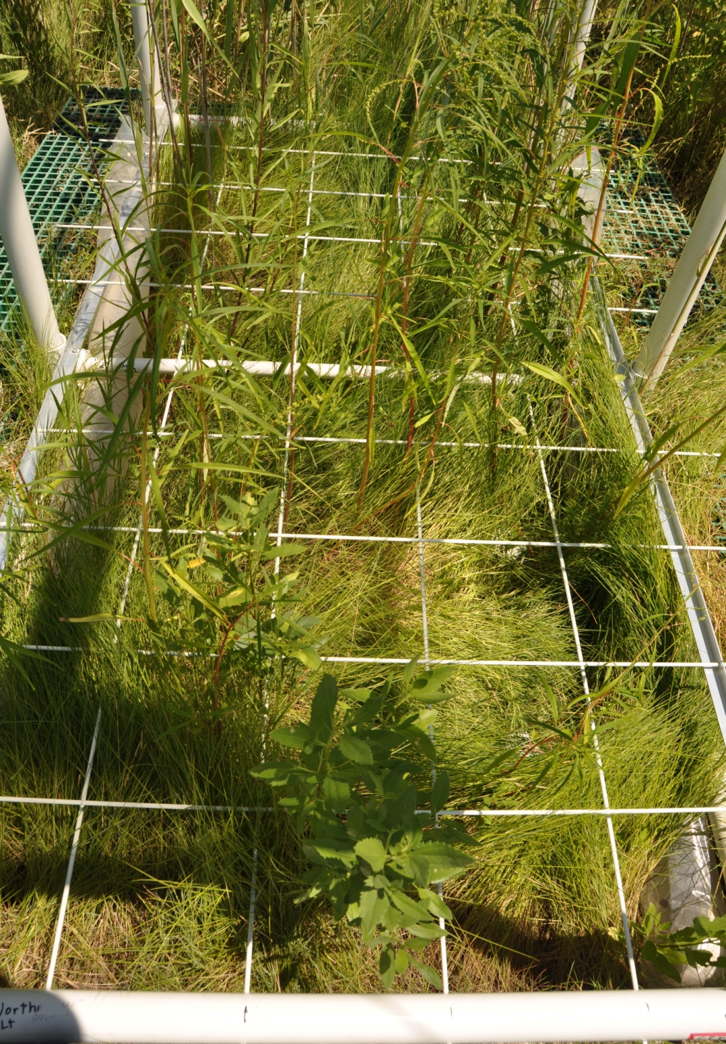

The plot layout is as follows:
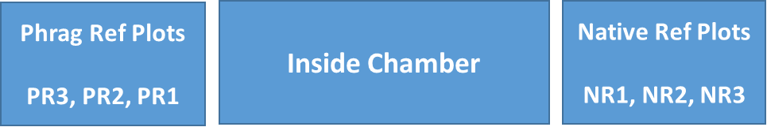

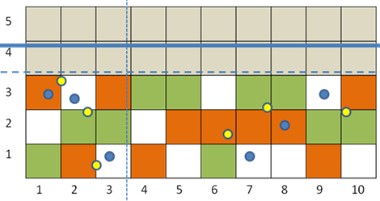
A
B
D
E
C
PR1
NR3
NR2
PR3
NR1
PR2

Figure 1. Different census activities among subplots. Orange cells are clip (harvest) plots. Green are the only subplots used for measuring the dimensions of all SCAM stems in cell. White subplots are set aside for other uses and are censused only for Phragmites. Grey subplots are set aside for SET measurements but are censused for the allometry species (no harvests done).

- Within each quadrat (quad) the sampling is performed by three different teams. One team measures Phragmites using a single “Phragmites” datasheet. The second team measures Schoenoplectus, and the third team measures all other species.

- It is best to only having 1 team in a chamber at a time so that there is ample space to move around the chamber catwalks to access the grid and reference plots.

- When one group finishes their portion of census. The grid will become available for the next team to follow up with their portion of the census.

- There are 6 sets of Grids. Teams will be spread across the project working on several chambers at the same time doing different tasks.

Phragmites Group:

The Phragmites group has three people: (1) measurer, (2) recorder and (3) leaf sampler.

Each quadrat must be sampled. Although the order of quad sampling is not critical, it is helpful if it is done in an orderly pattern to avoid errors. For this reason, progress through the quads by either column (numbered) or row (lettered).

Phragmites Measurer:

- Measure the height (to nearest cm) of each individual Phragmites plant
- If height >200 cm measure stem diameter at sampling grid height (~40 cm)
- Note presence of flower (record “Y” or “N”)
- Note presence of herbivory and type if known (record G, L or A) G=Gal, L=Lipara A=Aphids
- Take 3rd or 4th leaf from the top and place into coin envelope and label with date, chamber #, column (number), row (letter), and stem # within quadrate. Leaves are placed in a plastic Ziploc bag then desiccant is added at the end of the day to preserve the samples for genetics.
Recorder:
- Enter Reader Name, Recorder Name, Date onto data sheets
- Use Subplot Col# and Row to record data of Height, Diameter if height >200 cm
- Note presence of flower (record “Y” or “N”)
- Note presence of herbivory and type if known (record G, L or A) G=Gal, L=Lipara A=Aphids
- The Recorder should remind or ask Measurer to provide any information they may have not given. Every column should be filled out for each entry.
- For consecutive number rows not used they should cross those sections out.

Leaf Sampler:

- Write on coin envelope Phragmites Leaf Archive Label Chamber #, Column, Row, Plant # and Date.
- Collect leaf from Measurer. Fold the leaf up and put into labeled coin envelope.
- Collect leaves in a bucket while working.
- After all leaves are collected for the entire chamber. Which includes the inside of the chamber, the native reference, and phragmites reference. Take the collection of leaves and store them into a jumbo sized pre labeled zip-loc bag. The prelabeled zip-loc bag will have fields for chamber #, Date collected, Leaf collector’s names and a box to check when the desiccant has been added. Fill in all information onto the label accordingly.

Note: Reference plots are completed by each team specialized to each task
Other Species Group:

The other species group requires 2 members. But also, can operate with 3. 1 recorder and 1-2 measurers.

- Grasses, Phragmites and Schoenoplectus plants are not counted. Clip plots are taken in the prescribed “grass plots” the phragmites and schoenoplectus will be counted and measured by other groups during the census.

- All other species will need to be identified. There are guides to help with identification. After identification of the species, you will need to use the proper species code that correlates to that plant.

- Each plant is measured for stem height. If the plant is less than 40 cm you will not need to collect a diameter. For all plants greater than 40 cm you will need to collect diameter using calipers at the sampling grid (~40 cm)

Exceptions: Aster, Iva, and Solidago have different protocols than all other species.

Aster: due to the large density found in some plots and the grass like nature. We are only getting a density number for aster plants.

Solidago: adolescent solidago plants that have not formed a main stem will only have leaves forming from the soil. If there is not a main stem formed, bunch up the leaves and get a measurement to the highest point. make a note on the datasheet “leaves only”

Iva: (2024) due to the bushy woody nature of Iva’s stems. As the plant matures, they pose a threat to the integrity of the panels. In 2024 we plan to measure each of the Iva plants to the highest point get a measurement of the main stem at grid height (approx. 30cm) Then we will harvest the entire plant. We will dry and weigh Iva to verify the allometric model.

Note: Reference plots are completed by each team specialized to each task
Schoenoplectus (SCAM) Group

The SCAM species group requires 2 members. But also, can operate with 3. 1 recorder and 1-2 measurers.

- Use the “Schoenoplectus” datasheets. Determine if you should use the full set of datasheets or the datasheet for “SCAM in sparse chambers datasheets”. Sparse chambers have less than 30 stems throughout the whole chamber.

- In Each Column number (1-10) there is one row that is designated as an allometric subplot on the data sheet. In the subplot map (Figure 1), allometric subplots are identified by green blocks. This figure can also be found inside of your clipboard on your Phragmites experiment guide sheets. The designated allometric subplots are A1, B2, B3, C4, C5, A6, C7, C8, B9, and B10.

- In all subplots (excluding the allometric subplots), count and record the number of SCAM plants. No data are needed on heights.

- In allometric subplots measure the total height, green height, and width of each stem. Also, for each stem note whether it has a flower (F), no flower (N), or has been cut (C) such that the presence of a flower cannot be determined.
- Very important – For chambers identified as “SCAM in sparse chambers” measure the allometric parameters (heights and diameter) on up to 25 plants per chamber. There is a special datasheet for subplots with sparse SCAM.

Note: Reference plots are completed by each team specialized to each task
Harvest: (Note: This will normally be done by Tom Mozdzer but has been performed by Adam Langley in 2020 and by Maci Schimon in 2022)
- Harvest all of the stems in 10 C4 subplots highlighted with Orange in figure.
A
B
D
E
C

- insert a three-sided subsample quadrat 7 cm x 7 cm (i.e. square missing one side).

- Complete the fourth side of the square by circling your thumb and finger to close the open end of the template.

- Grab the vegetation (live or dead) rooted therein and clip the plants within 1 cm of ground. You will need to cut all of the material within the three-sided subsample quadrat while avoiding any phragmites stems.

- Place the vegetation in a large paper bag pre-numbered with chamber number and plot information. Take these bags to the lab for sorting.
Sorting (Note: Ask for Help Identifying Plants!)
- Separate into four categories:
  - Schoenoplectus: The sedges have edges and are easiest to separate. Separate green sedge from brown sedge. Define ‘green’ any stem that has a green part, no matter how small. Count the number of green stems as you are sorting. Put completely dead material in a discard pile. On the “harvest” data sheet, Schoenoplectus section, record the number of sedge stems. Go to step 2.

  - Spartina: The fine flowing grass. Separate green grass from brown grass. Define ‘green’ any stem that has a green part, no matter how small. Put completely dead material in a discard pile. Count the number of green stems as you are sorting, record the number on the Harvest datasheet in the Spartina section. Go to step 2.

  - Distichlis: The striped, thick-stemmed grass. Again, count as ‘green’ any stem with a green part, no matter how small. Put completely dead material in a discard pile. Count the number of stems as you are sorting and record the number in the Distichlis section. Go to step 2.

  - Other Species: Identify other species and count the number of stems. Be sure to ask for help identifying plants. Separate green plants from brown plants. Put completely dead material in a discard pile. Count as ‘green’ any stem that has a green part, no matter how small. Record the ID of the species and the number of stems first under Misc #1 or else Misc #2. A table of IDs for each species is available on the sorting tables. See step 2.

- Before putting the samples into their respective bags, rinse all samples by swishing them in dip bucket to remove salt, silt, or dirt.

- After sorting, try to weave the grasses into little bundles; it will be much easier to weigh after it's dry, otherwise it gets brittle. Place each of the remaining categories (Spartina, Distichlis, or Other) in their own bags (i.e. you do not need to keep any of these stems in separate bags the way you did for Schoenplectus).

- Use bags pre-labelled with “Phrag X CO2 X N” fill out Chamber, Quad (quadrat), Species, Stem Count and stamp the date.

- On the mass sheet checklist, place enter the number of stems in the appropriate column as you go. Most quadrats won’t have all four categories, so we need to keep track of the quadrats that produced samples vs those that did not – so put a zero (0) in blank cells to indicate there was no sample.

- Discard the dead stuff.

Directions for samples post census and harvest

After the census and harvest have been completed. There are 2 major collections. 1. For sorted harvest biomass sample bags, 2. For coin envelopes with phragmites leaf samples. Each of the sample collections will need clear decisions for whom will be in charge of taking custody of where the samples should be stored and analyzed. These decisions should be made prior to the census.

- The sorted harvest biomass sample bags.
- Most years the biomass samples will be brought back to Bryn Mawr with Thomas Mozdzer then processed by students. Biomass samples brought back to Bryn Mawr will need to be tracked with ‘annual tracking spread sheets’ specifically when the samples are returned back to SERC and custody of samples is changed.

- Other years the samples will stay at SERC and processed by technicians. Technicians should follow ‘annual tracking spread sheets’ while processing data.

- The coin envelopes with phragmites leaf samples.
- These leaf samples will be processed at SERC by Mellisa McCormick.

Processing for Weight
- Place sorted samples in the drying oven for at least 96 hours @ 60 C. The bags should be spaced appropriately, not too crammed together, so that each is exposed to moving air and can fully dry.

- Find or reprint “PhragxCO2xN Harvest Data” Sheets collected during the annual harvest. This is where you will be recording the mass.

- Be prepared to weigh the bags shortly after removing them from the oven. Remove dry bags from oven, allow them to return to room temperature for 20 minutes.

- Use standard 50g and 1g weights to check calibration of scale, and record values on mass data sheet. Remove the sample from the bag and weigh it on a balance with at least 3 decimal places. Record weight in corresponding cell of the mass data sheet to 3 decimal places.

- After weighing samples from a single chamber, consolidate samples according to species into four sections: Phragmites Reference (PR), Phragmites (Plots 1-5), Native (Plots 6-10), and Native Reference (NR). Put all the green stems from a single species and section into a single bag for grinding. Label consolidated sample bags clearly with Experiment, Year, Chamber #, sample Species Code (SCAM/ SPPA/ DIST) and section (PR/ Plots 1-5 / Plots 6-10 / NR).
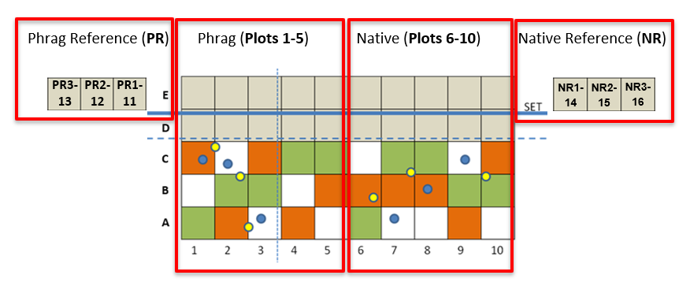
- This step is only for Schoenoplectus stems: remove any dead areas from the stems prior to consolidation. Remove brown tip and sheathing on base of the stem.

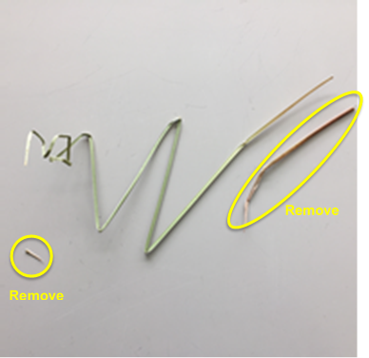

Grinding
Labels
- Prior to grinding 20mL scintillation vials need to be labeled. Start by opening vial labelling document and printing on weatherproof address labels.
S:\Biogeochemistry\GCREW\3-PhragmitesxCO2xN Experiment\1-Plant Biomass & CN Data\Shoot Biomass Data\Census-Harvest Toolkit\Labels “Phrag Aboveground vial labels”
- Use the weight data from the Harvest Data Sheet to figure out which plots need vials. Samples of the same species have been combined for each chamber and section (PR/ Plots 1-5 / Plots 6-10 / NR). Look at data for each chamber individually to see which species are present. A vial and a label are required for each species present. Go through each chamber one at a time, adding labels to vials as you go. Put vials back into the box in order until all 12 chambers are done.
- After all side labels have been added, label the caps of the vials with the information shown below, using the corresponding side labels as reference.

Year Phrag x CO2 x N Ch# / Plots Species

2020 Phrag x CO2 x N Ch 1 Plots 1-5 SCAM

Example

Pre-Grinding Steps
- After vials and tops are labelled, organize harvest bags to correspond with the order of the labeled sample vials.
- Check each paper bag to see how much sample is inside. When there are more than 1 grass or schenoplectus stems, cut stems into smaller pieces with scissors or for larger samples use coffee grinder. The coffee grinder will have to be cleaned between each use.
- Print Grinding checklist to keep track of progress as samples are processed.
S:\Biogeochemistry\GCREW\0-GCREW-Wide Data\1-Sample Tracking\Shoot Biomass\3-Phragmites Shoot Grind Checklist.xlsx
How to Grind Samples
- Prior to starting find 4 stainless steel capsules next to grinder remove O-ring from the lids scrub O-ring and capsules with Ethanol to remove any sample traces from other experiments. After scrubbing everything down with ethanol rinse thoroughly with DI and dry with Kim Wipes.
- Open the lid of the grinder and inspect the belt look that it’s set on the track and there in no dry rot or nicks to the belt. Look at ball joints where the capsules spin. Look for rust and move the joint around with your hands feel for resistance. If there is rust or resistance spray joints with WD-40 and move them around.
- Turn on switch located on the back panel on the lower right corner. Set the time to 7 minutes 30 seconds.
- Fill capsules ¼ or less full. Secure the lid tightly and put capsules into the mixer mill.
Note: If capsule is too full the plant material will not grind to fine powder.
- Close the Lid and hit the start button. While samples are in the mixer mill listen for sounds that may indicate the capsule has loosened. Be prepared to hit the stop button or cut the power by flipping the switch in the back.
- While one set is grinding, start processing the previous set of samples and start preparing the next set of samples to be ground.
Data Processing
- All field sheets should have been scanned at the end of the day and stored on the network. Scan the mass datasheets generated in the lab as well.

- In preparation for data processing, refer to the steps outlined in the Harvest & Census Data Entry Workflow Chart.

